Q 1 Java program to print welcome message.

CODE🡪

package Day2_3;

public class wellcome {

public static void main(String[] args) {

System.out.println("well come");

}

}

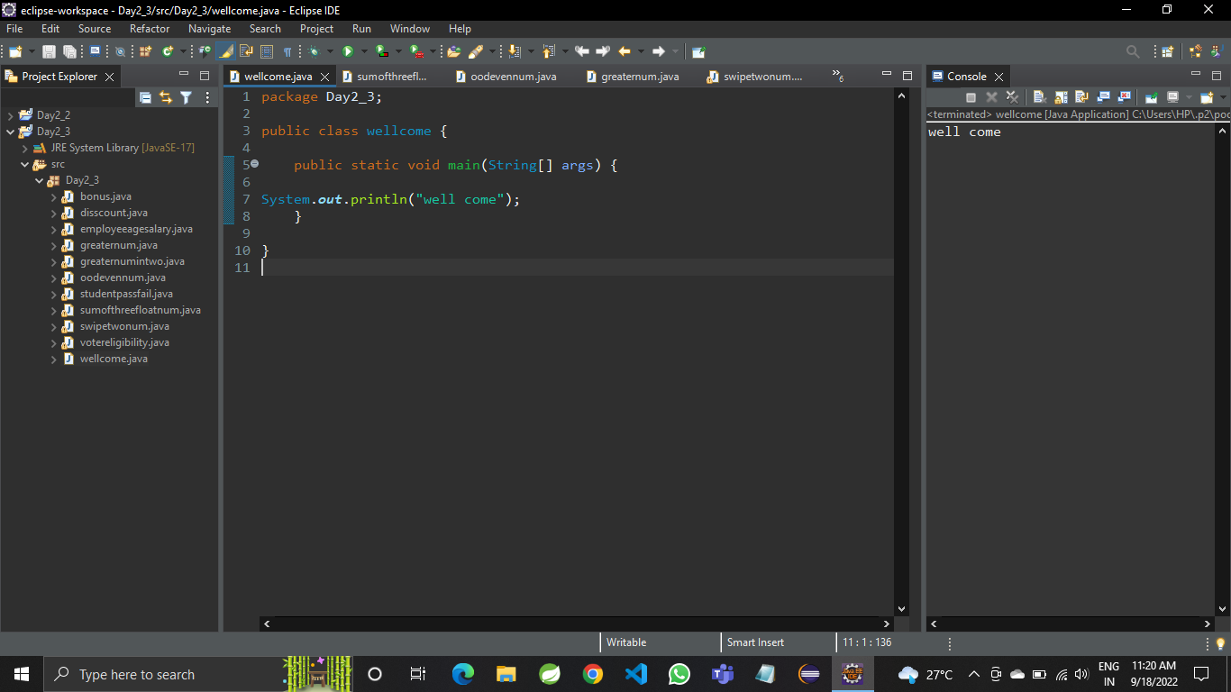

Q 2 Java program to print sum of  three float numbers

CODE🡪

package Day2_3;

import java.util.Scanner;

public class sumofthreefloatnum {

public static void main(String[]args) {

float a;

float b;

float c;

float addition;

Scanner sc= new Scanner (System.in);

System.out.println("inter the value a");

a=sc.nextFloat();

System.out.println("inter the value b");

b=sc.nextFloat();

System.out.println("inter the value c");

c=sc.nextFloat();

addition=a+b+c;

System.out.println("addition : " + addition );

}

}

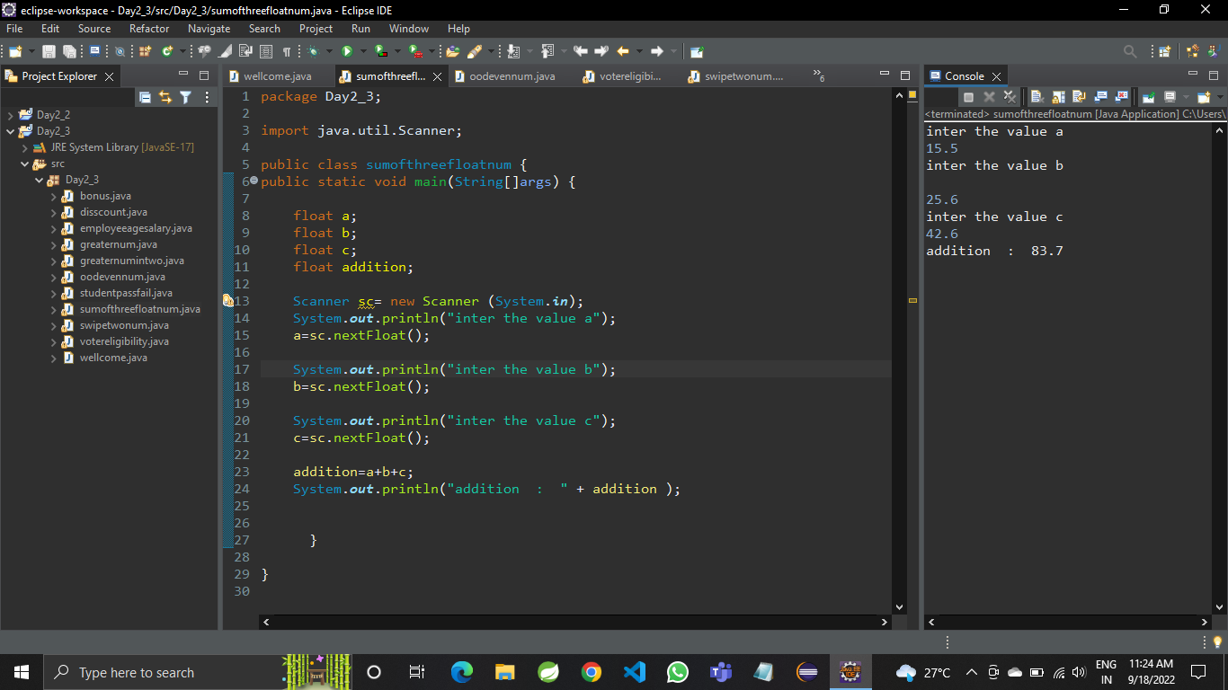

Q 3 Wap to check if number is even or odd 

CODE🡪package Day2_3;

import java.util.Scanner;

public class oodevennum {

public static void main(String []args) {

int num1;

Scanner sc=new Scanner(System.in);

System.out.println("enter num1");

num1=sc.nextInt();

if(num1/2==0) {

System.out.println("num1 is even");

}

else {

System.out.println("num1 is odd");

}

}

}

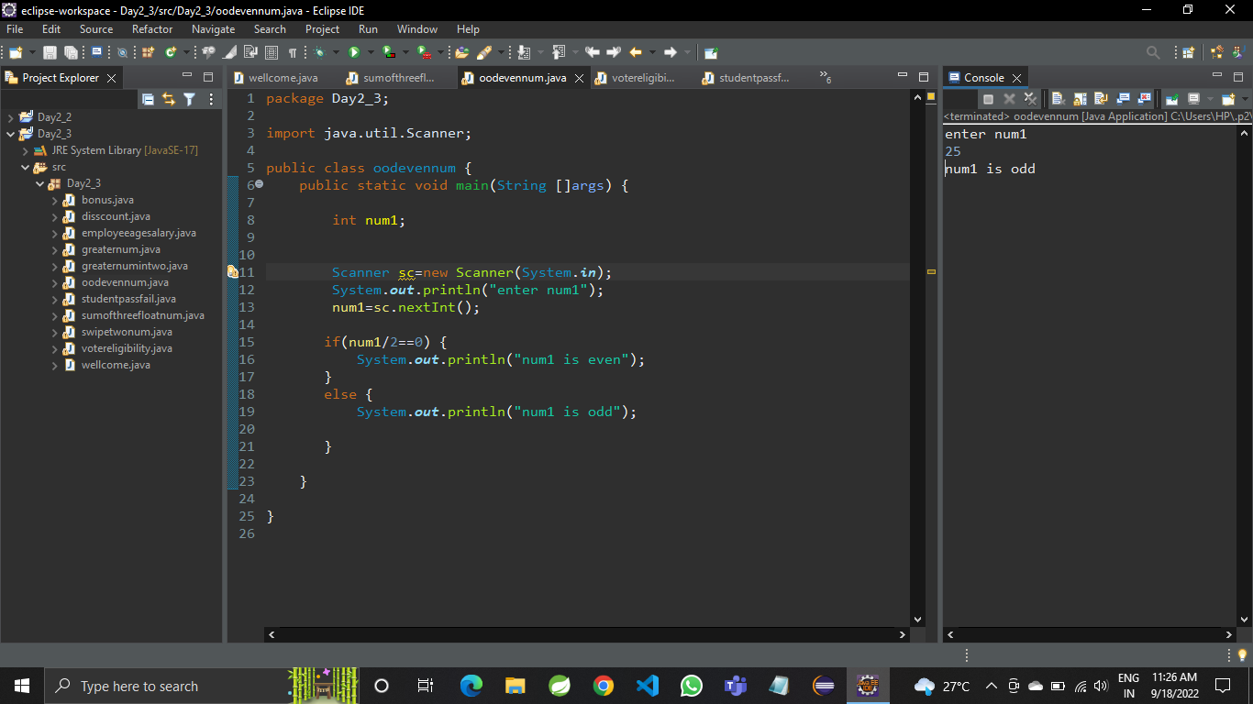

Q4 Java Program to Swap Two Numbers

CODE🡪

package Day2_3;

import java.util.Scanner;

public class swipetwonum {

public static void main(String[] args) {

int a;

int b;

int c;

Scanner sc=new Scanner(System.in);

System.out.println("enter the value a and b");

a=sc.nextInt();

b=sc.nextInt();

System.out.println("initial value :"+a+" & "+b);

c=a;

a=b;

b=c;

System.out.println("final value: "+a+" & "+b);

}

}

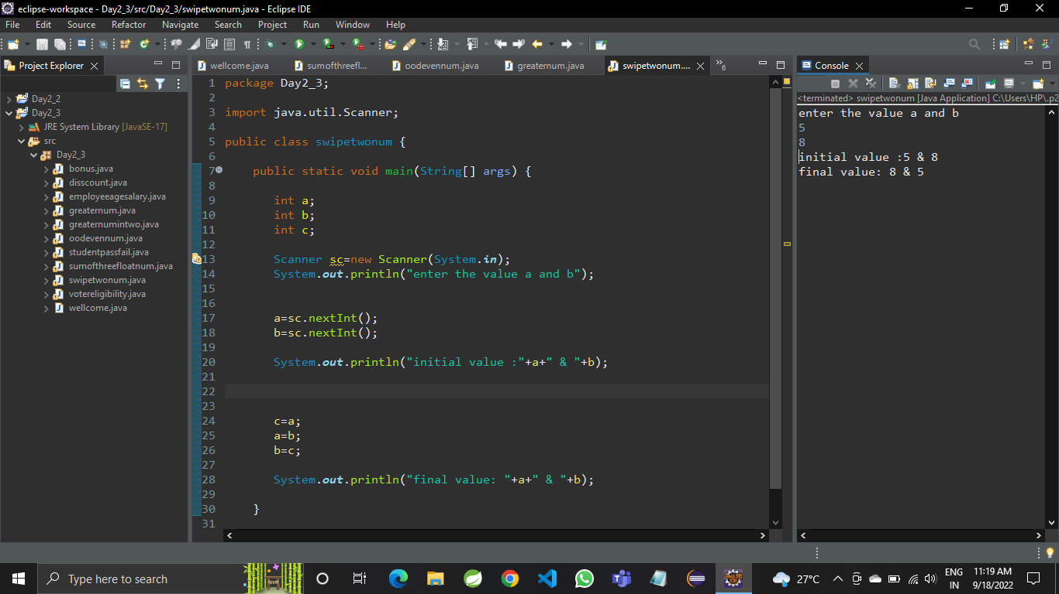  
  
Q 5 wap to check from three given number  that whether a number is greater than or equal to 20 and less than other numbers .print appropriate message .

CODE🡪

package Day2_3;

import java.util.Scanner;

public class greaternum {

public static void main(String []args) {

int num1=25;int num2=18;int num3=19;

if(num1>20 && num1>num2 &&num1>num3);

System.out.println("num1 is greatest");

}

}

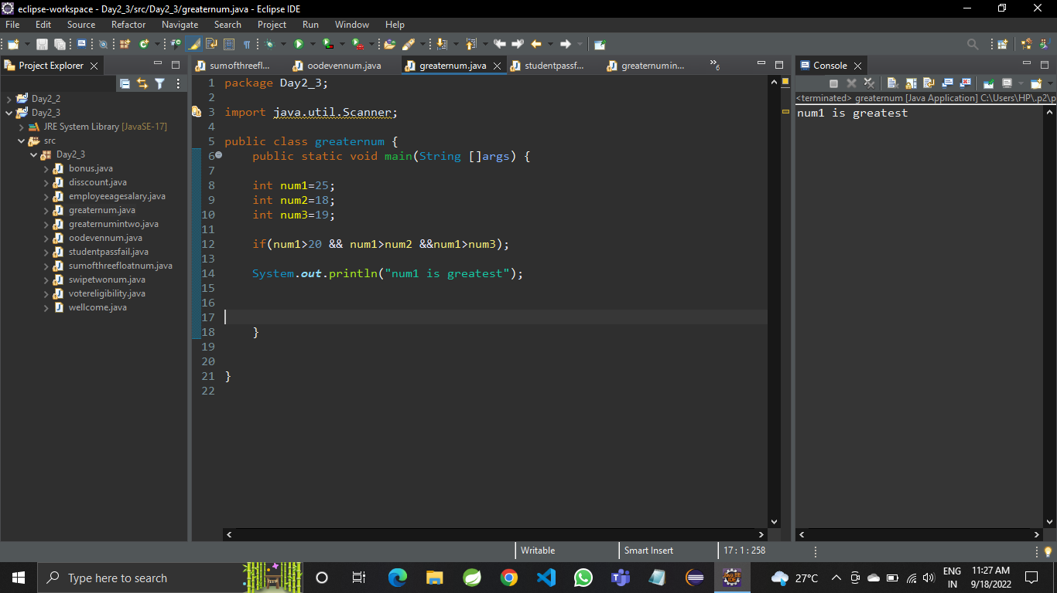

Q 6 wap to check if sales of a person is greater than 10000 then eligible for bonus   
else not eligible calculate bonus as 20% of sale

CODE🡪

package Day2_3;

import java.util.Scanner;

public class bonus {

public static void main(String[] args) {

int a;

Scanner sc= new Scanner(System.in);

System.out.println("enter value a ");

a=sc.nextInt();

if(a>10000) {

System.out.println("sales man eligible for bonus");

}

else {

System.out.println("salesman not eligible for bonus");

}

}

}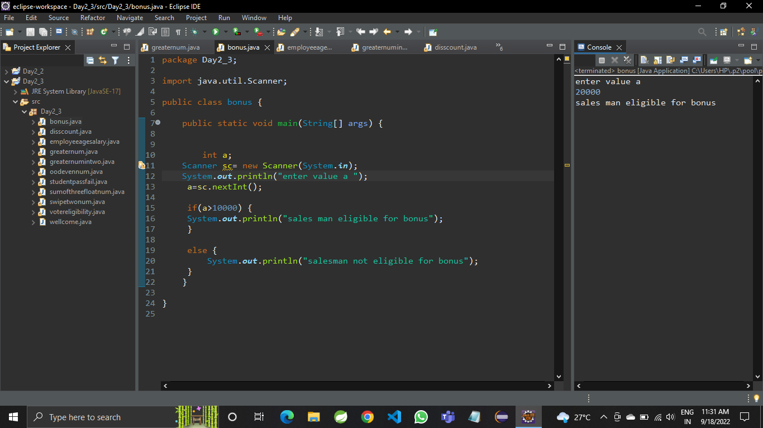  
Q 7 wap to check if two given integer value is in range of 18 and 100 print eligible for voting else not eligible .

CODE🡪

package Day2_3;

import java.util.Scanner;

public class votereligibility {

public static void main(String[]args) {

int a;

Scanner sc= new Scanner(System.in);

System.out.println("enter the value a");

a=sc.nextInt();

if(a<18||a>100) {

System.out.println("voter is not eligible ");

}

else

{

System.out.println("voter is eligible");

}

}

}

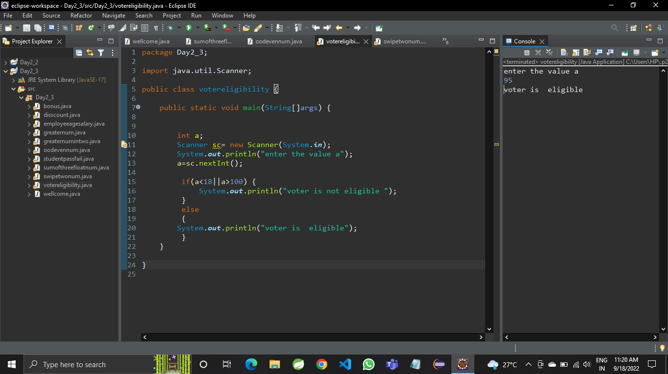

Q 8 wap to print average of  given five subjects marks of student and check if average >=40 print Pass else print fail

CODE🡪

package Day2_3;

import java.util.Scanner;

public class studentpassfail {

public static void main(String[] args) {

int a;

int b;

int c;

int d;

int e;

int avg;

Scanner sc=new Scanner(System.in);

System.out.println("enter the value a");

a=sc.nextInt();

System.out.println("enter the value b");

b=sc.nextInt();

System.out.println("enter the value c");

c=sc.nextInt();

System.out.println("enter the value d");

d=sc.nextInt();

System.out.println("enter the value e");

e=sc.nextInt();

avg=(a+b+c+d+e)/5;

System.out.println("avg : "+avg);

if(avg>=40) {

System.out.println("student is pass");

}

else {

System.out.println("student is fail");

}

}

}

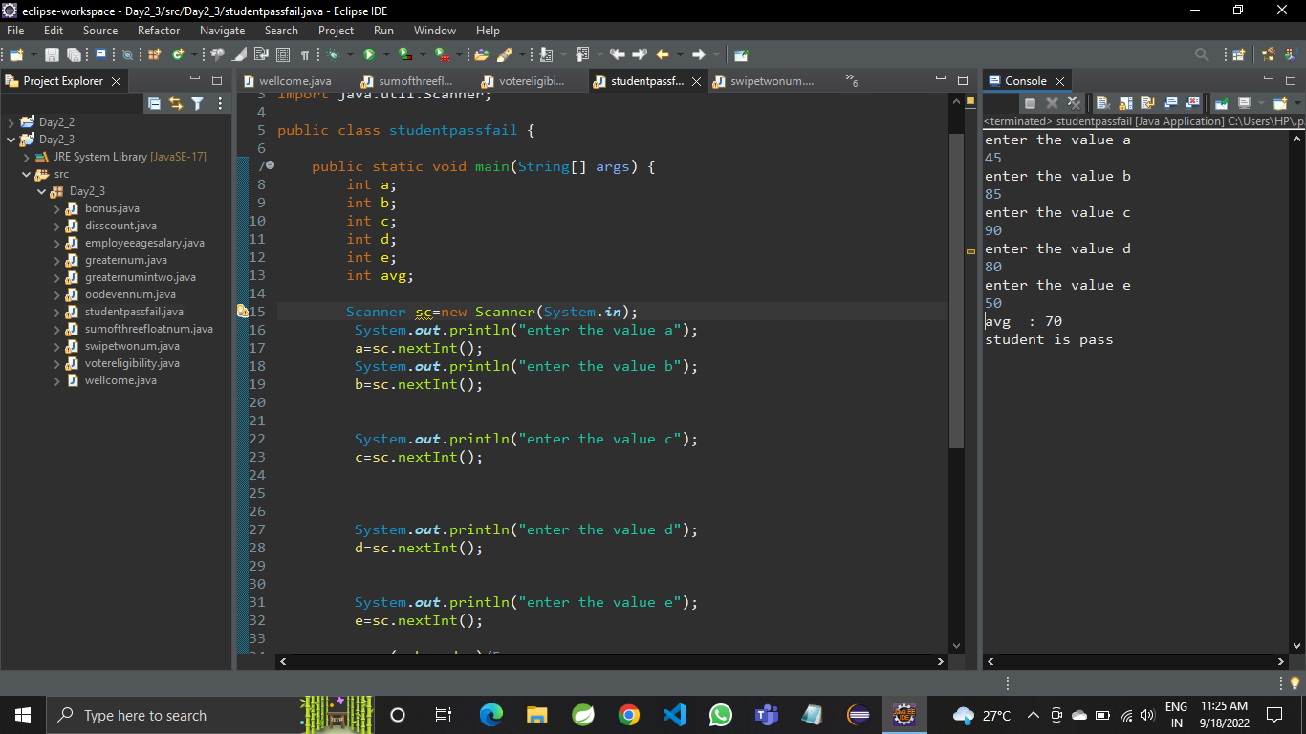  
  
Q9 WAP to ask name ,age and salary of an employee and print on console.

CODE🡪

package Day2_3;

import java.util.Scanner;

public class employeeagesalary {

public static void main(String[] args) {

String name;

int age;

double salary;

Scanner sc=new Scanner(System.in);

System.out.println("enter the name");

name=sc.next();

System.out.println("enter the age");

age=sc.nextInt();

System.out.println("enter the salary");

salary=sc.nextDouble();

System.out.println("name :"+name +" age:"+age+ " salary: "+salary);

}

}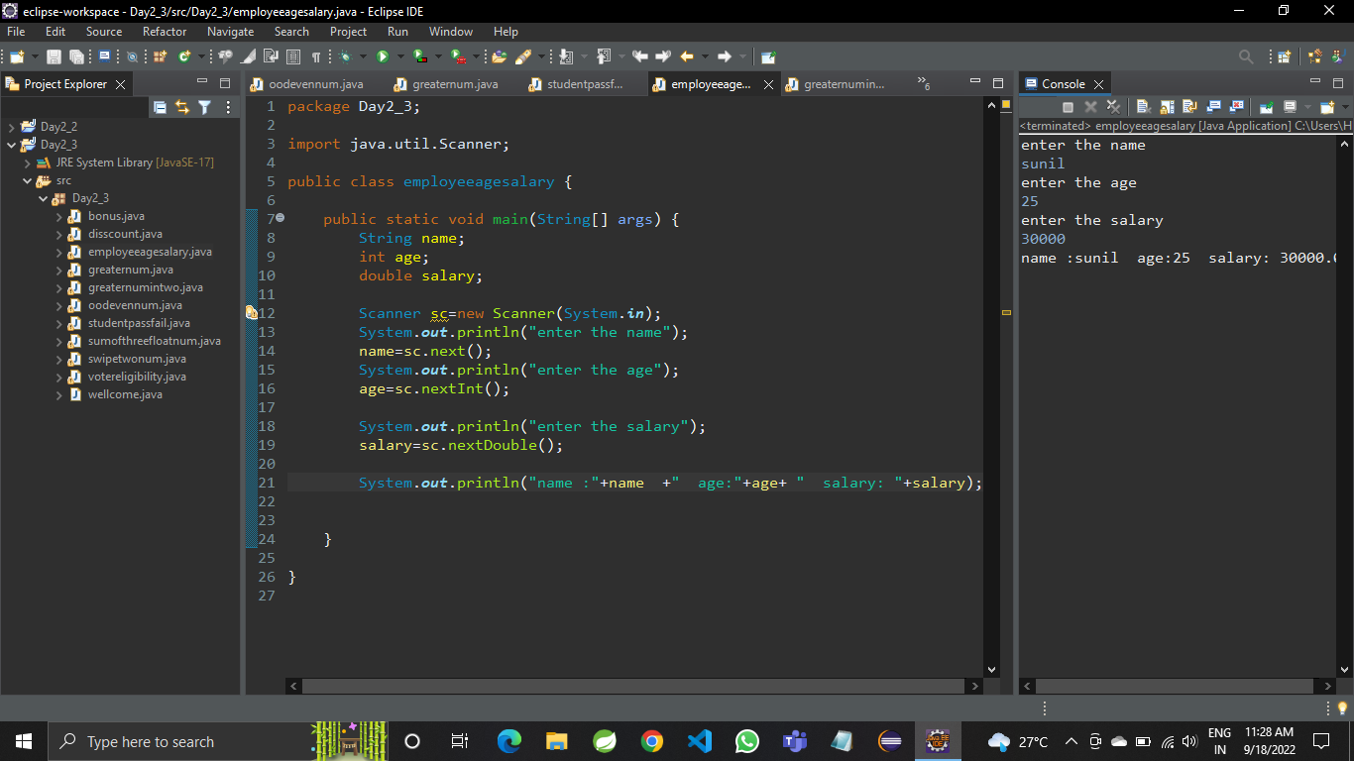  
Q 10 wap  that ask two numbers from user and print greater number among two

CODE🡪

package Day2_3;

import java.util.Scanner;

public class greaternumintwo {

public static void main(String[] args) {

int num1;

int num2;

Scanner sc=new Scanner(System.in);

System.out.println("enter num1");

num1=sc.nextInt();

System.out.println("enter num2");

num2=sc.nextInt();

if(num1>num2) {

System.out.println("num1 is greater");

}

else {

System.out.println("num2 is greater");

}

}

}

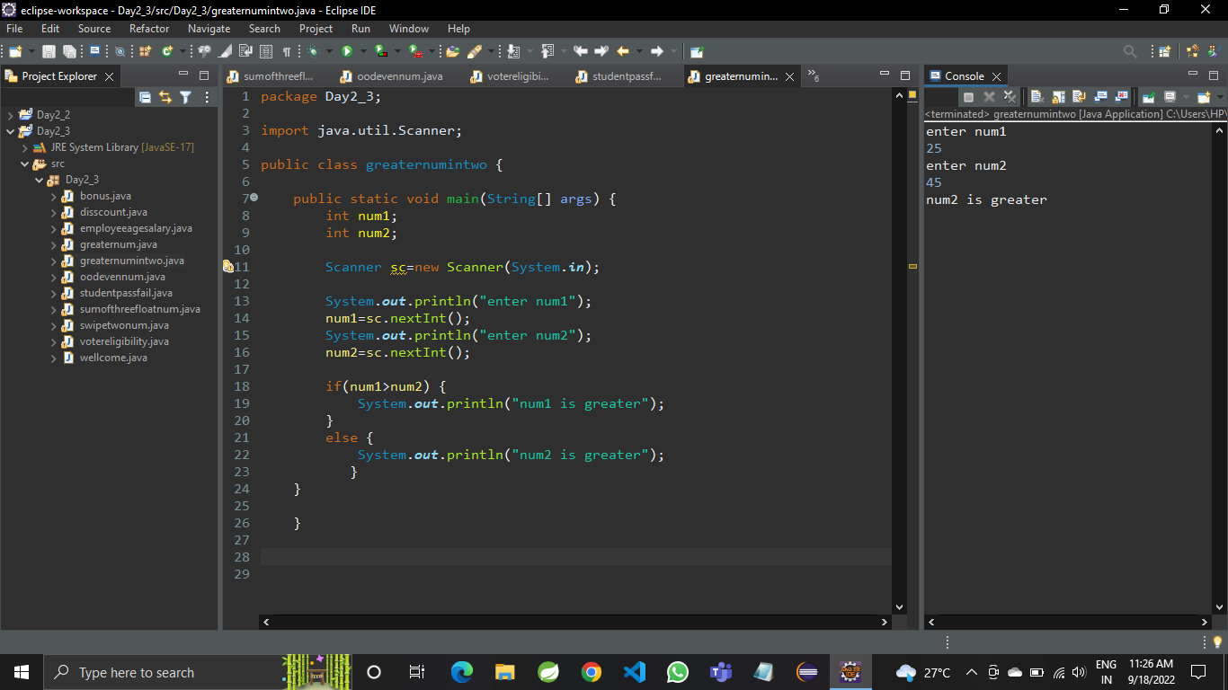

Q 11 wap to ask product name and price of product from user and calculate discount i.e   
if price > 2000 then discount is 10 percent of price   
else discount is 7 % of price

CODE🡪

package Day2_3;

import java.util.Scanner;

public class disscount {

public static void main(String[] args) {

String productname;

float productprice;

float disscount;

Scanner sc=new Scanner(System.in);

System.out.println("enter product name");

productname=sc.next();

System.out.println("enter productprice");

productprice=sc.nextFloat();

if(productprice>2000) {

disscount=0.1f*productprice;

System.out.println("disscount :"+disscount);

}

else {

disscount=0.07f*productprice;

System.out.println("disscount :"+disscount);

}

}

}

